
The IAS Newsletter
Vol. 42, No. 1 supplement – March, 2020
ISSN 2330-295X
A SUPPLEMENTAL PUBLICATION FOR MEMBERS OF THE INTERNATIONAL AROID SOCIETY

“Papa Don’t Leech”
A Horticultural Expedition Log through 4 Southeast Asian Countries

by Alan Galloway, Bjørn Malkmus-Hussein, David Prehsler and Derek Carwood
Countries Explored: Philippines, Vietnam, Thailand and Laos
10 August 2018 to 14 September 2018
Click here for the web-based version of this document with links to larger photos
Trip Participants
Alan Galloway (USA) –Adjunct Researcher, Juniper Level Botanic Garden
Bjørn Malkmus-Hussein (Spain) – Owner, Rare Flower Seeds and Plants & Pixelflora – Stock Photography
David Prehsler (Austria) – Dept. of Botany and Biodiversity Research, University of Vienna
Derek Carwood (USA) – Curatorial Horticulturist, Greater Des Moines Botanical Garden

All of the trip participants have interests in diverse plant families, but all 4 of us have a concentrated interest in Araceae and Zingiberaceae, and Southeast Asia is undoubtedly a prime geographical hotspot for these genera. This trip was the second time all 4 of us have visited Southeast Asia together. Like so many areas around the planet, this region is losing vast amounts of pristine and species-rich primary forest to infrastructure development and harvesting of natural resources, especially timber and limestone.

Friday, August 10, 2018
Alan’s flight departed Raleigh, NC at 7:50am and had a 2.5 hour layover in San Francisco.

Luckily it was a rather quiet flight from San Francisco to Taipei, Taiwan, so he was able to get some sleep, which was much needed considering he did not get any Thursday night packing for a 5 week trip. He had a 3½ hour layover in Taipei and arrived at Manila airport, Philippines at 11pm, but had to sit on the tarmac for another hour before debarking the plane since heavy rain had caused some delays. Alan went through immigration, picked up luggage, cleared customs without incident, and exchanged some US dollars into Philippine pesos. The Manila airport consists of 4 terminals, all being at quite some distance from each other, so he took a taxi from terminal 1 to a budget hotel, directly across the road from terminal 4 from which he would fly onto Palawan a couple of hours later that day.
Saturday, August 11, 2018

Alan had just enough time to take a shower and to repack his luggage. Since there is a strict weight limit on how much luggage one can carry on the inland flight from Manila to El Nido, he packed just enough clothes into a small carry-on luggage and his backpack, and left his larger piece of luggage at the hotel to be picked up on his return. Dr. Lanie Medecilo, a botanist at De La Salle University - Dasmariñas, Philippines had asked for some Amorphophallus DNA samples, so he left them at the hotel for her to pick up. The airplane left Manila at 5:55am and arrived in El Nido at 7:10am. Alan took a tuk-tuk from the airport to Raab’s Botanica coffee shop. The rest of the day was spent walking around El Nido and touring Raab’s plant collection. For the night the Amakan hotel was chosen right across the street from Raab’s Botanica coffee shop.
Sunday, August 12, 2018

Will Cabanillas, a tour guide and trekker from Puerto Princess City, joined Raab and Alan and we hiked up a karst mountain behind El Nido. Amorphophallus natolii was quite abundant there, growing amongst the karst rocks with quite a few of them being in fruit. The top of the mountain provided for some great views overlooking El Nido Bay. Our group returned to Raab’s coffee shop for lunch and a brief rest. After lunch we trekked up another mountain to see what Raab thought was Amorphophallus declinatus, but given that specimens observed had a roughish petiole, it may prove to be a different species. Several Begonia and Alocasia species were found on both of these mountains. Will and Alan spent the night at Raab’s house.
Monday, August 13, 2018
Sunday, August 12, 2018
Alan’s pics for August 13, 2018:
All photos copyright 2018 to present – Alan Galloway
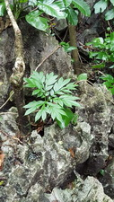 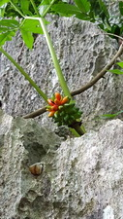  Amorphophallus natolii | 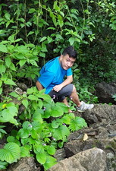  RAAB with  Epithema cf. madulidii
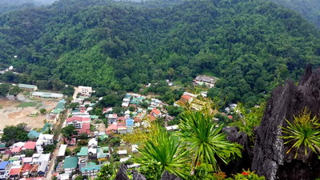 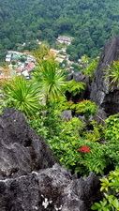  Overlooking El Nido | 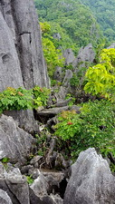  Karst Mountain above  El Nido

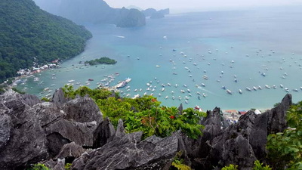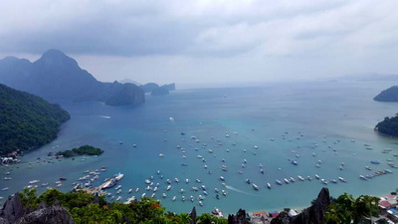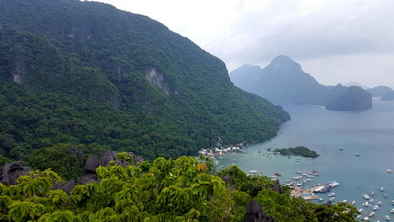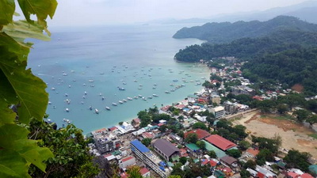
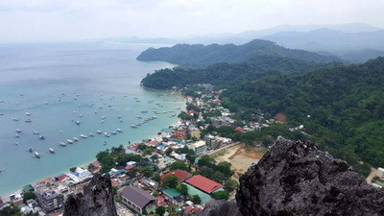 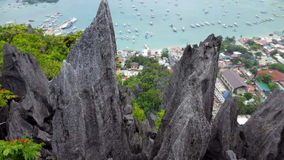
Overlooking El Nido Bay
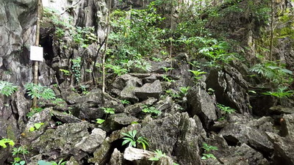Amorphophaollus natolii | 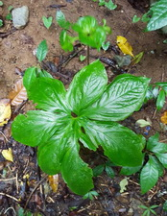  Tacca palmata

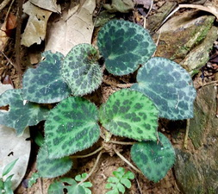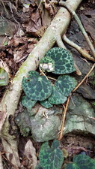  Begonia cf. tagbanua | 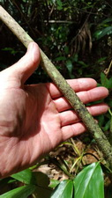 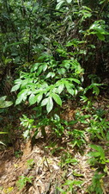  Amorphophallusw cf. Declinatus
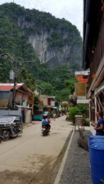  El Nido (Botanica Coffee Shop) | 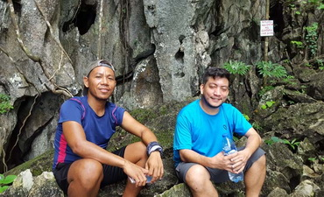  Will Cabanillas and RAAB

Will and Alan departed from El Nido at 6am, taking a couple of shuttle van rides south and then taking a 1 hour boat ride to Damaron Island. Once on the island we took a 1-hour motorbike ride to Araceli, where we had dinner with Will’s friends, Dickie Coronia Rodrigues and Bradley Dowenz. The night was spent in a hotel in Araceli.
Tuesday, August 14, 2018

Alan’s pics for August 14, 2018:
All photos copyright 2018 to present – Alan Galloway
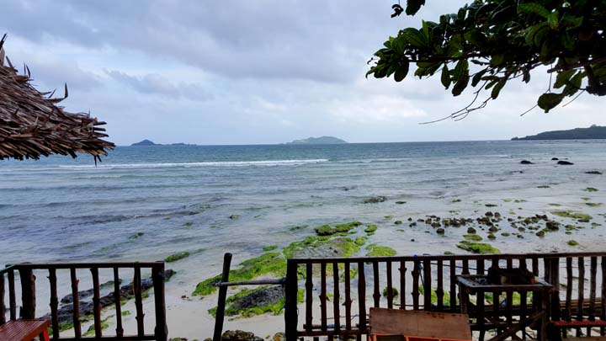
Overlooking the Sulu Sea

Will and Alan, along with Dickie and Bradley, took a 1 hour boat ride to an uninhabited island to see a new species of Amorphophallus species Will discovered a few years earlier. Just as we started the trek up the mountain Alan took a very nasty fall and injured his left elbow. Within minutes he was not able to move his elbow anymore and was worried he had broken it. Facing the exciting possibility of finding a new species, Alan forgot about the pain, and he was able to make it up the mountain with only one good arm! The new species was growing on slopes in shaded areas and several plants had nearly-mature fruit. Once back down from the mountain the guys spent a few hours snorkeling and fishing, while Alan stayed on the boat with an injured arm. Back in Araceli, we bought some fish at a local market, which Will and Dickie grilled to perfection!
Wednesday, August 15, 2018
Alan’s pics for August 15, 2018:
All photos copyright 2018 to present – Alan Galloway
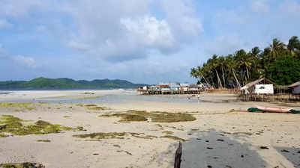  Damaran Island | 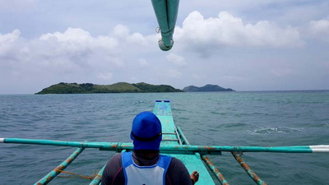  Boat Riding the Sulu Sea
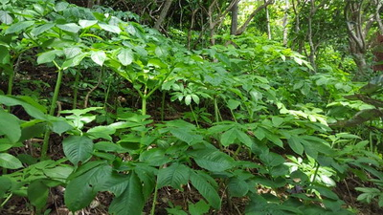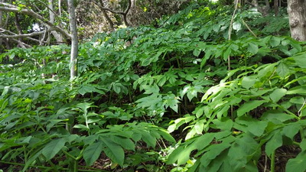
Amorphophallus species

Will and Alan took a 6 hour boat ride from Araceli back to mainland Palawan. Will headed back to Puerto Princess and Alan took a 3 hour shuttle van north back to El Nido.
Thursday, August 16, 2018
Alan’s pics for August 16, 2018:
All photos copyright 2018 to present – Alan Galloway
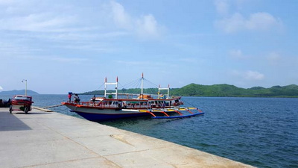 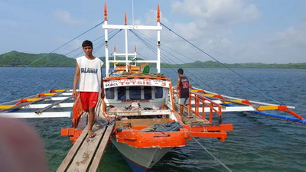
Boatride back to Palawan

Since Alan still could not move his arm he went to a medical center in El Nido and got an x-ray of his elbow. Luckily, there were no broken bones, just a severly bruised elbow in rainbow colors! The doctor gave him some great pain killer medications.
Friday, August 17, 2018
Alan’s pics for August 17, 2018:
All photos copyright 2018 to present – Alan Galloway
  Winner of the Best “No Smoking” Sign | 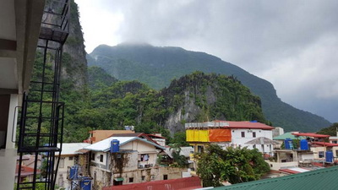  El Nido
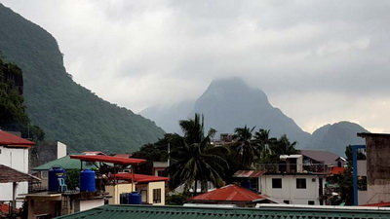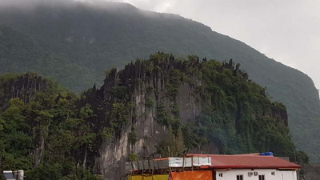
Karst Mountains behind El Nido

Alan spent the morning walking around the edge of El Nido City. In a forested area in the vicinity of the town, he found more plants of the ‘roughish petioled’ Amorphophallus species, with several plants having mature fruit. After lunch Raab and Alan took a trip around the northern tip of Palawan. At one of the stops at a karst mountain they found an Amorphophallus species growing with a few ripe seedheads. On the way back to El Nido, they stumbled across another Amorphophallus species growing at the edge of a corn field with several large ripe seedheads.
Saturday, August 18, 2018
Alan’s pics for August 18, 2018:
All photos copyright 2018 to present – Alan Galloway
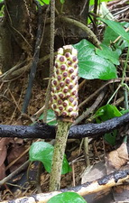  Amorphophallus cf. declinatus | 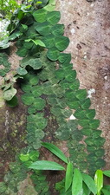  Clinging vine
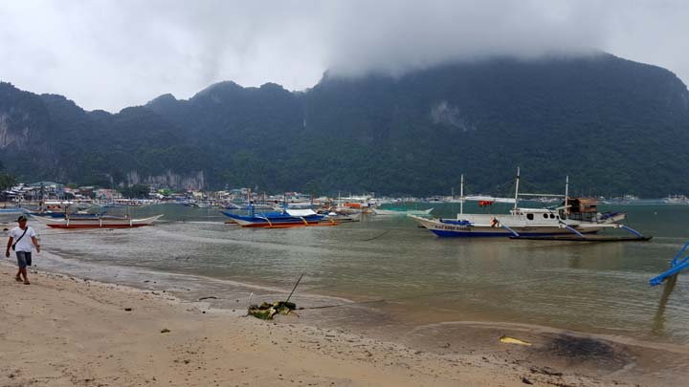
El Nido Bay

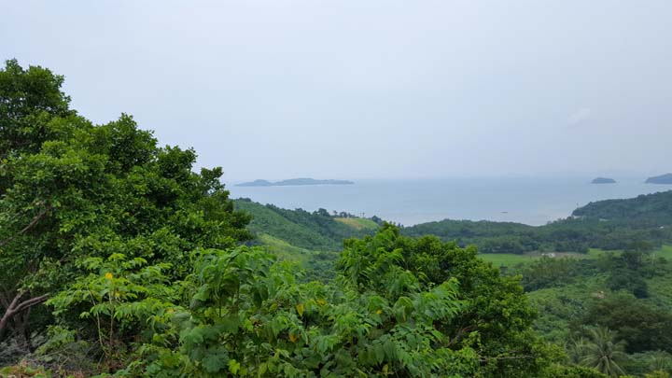
Overlooking El Nido Bay

Alan’s pics for August 19, 2018:
All photos copyright 2018 to present – Alan Galloway
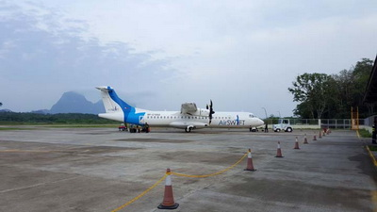
Airplane between Manilas and El Nido
Alan left the hotel via a tuk-tuk at 5am for the El Nido airport. He arrived at terminal 4 in Manila, picked up his luggage across the street at the hotel and then took a taxi to terminal 2. It took 3 hours to check in and go through immigration. A Chinese aircraft ran off the runway Friday and delays lasted 3 days. Because of the long delay leaving Manila he was extremely late catching his connecting flight in Ho Chi Minh City, Vietnam. As soon as he stepped into the terminal in Ho Chi Minh City there were 3 Vietnam Airlines staff members waiting for him. They called ahead and asked the national flight going to Hanoi to wait for him. Since he had to change terminals in the rain, two of the staff members held umbrellas and the third staff member helped him with the luggage. They even escorted him to the front of the security line so he could catch the flight to Hanoi. If only all airlines ranked customer service as much as Vietnam Airlines! Alan arrived at Hanoi airport aboaut 9pm, exchanged some US dollars for Vietnam dong and checked into a hotel very near the airport.
Sunday, August 19, 2018

Son Hoang, Vietnamese Academy of Forest Sciences, and the driver picked Alan up at 8am and we drove north to Na Hang. Since it took most of the day to get to the hotel, there was no time to make any stops along the way.
Monday, August 20, 2018
After breakfast Son Hoang and Alan hiked up a mountain in Na Hang Nature Reserve. Arisaema lihengianum was one of Alan’s ‘target’ plants to locate and photograph on this trip. Since Son Hoang had written a paper in 2015 on finding this species in Vietnam, they had no problems locating it. About halfway up the mountain they found it in a couple of spots growing in pockets of dark humus soil amongst rock boulders. Unfortunately flowering season was May and the plants could only been admired in leaf. Son Hoang pointed out an epiphytic Hedychium species he discovered earlier that is in the process of being described. This area was rich in so many plant families. Seen along the path to the summit were Asarum balansae, an Aspidistra species with spotted leaves, the beautiful burgundy spotted petiole of Disporopsis longifolia, at least 2 species of Camellia, Amorphophallus tonkinensis and A. coaetaneus and some huge trees of Magnolia conifera.
Near the summit is a reserve forestry station and since we arrived there at mid-day the staff invited us to stay for lunch. Afterwards the forestry staff guided us the rest of the way to the summit. By the time Son Hoang and Alan got back down the mountain and the driver picked us up, it was almost dark, so we quickly went back to the hotel and got cleaned up for dinner.
Tuesday, August 21, 2018
Alan’s pics for August 21, 2018:
All photos copyright 2018 to present – Alan Galloway
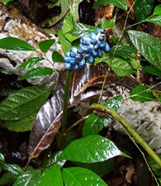 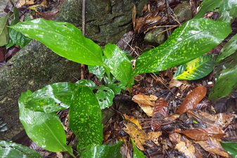  Amorphophallus coaetaneus seedhead |  | 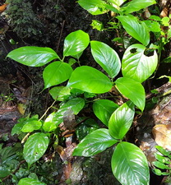  Arisaema lihengianum
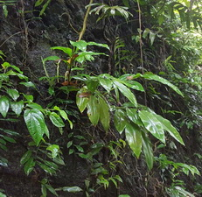  Hedychium species nova | 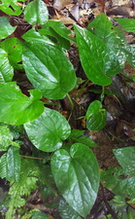  Asarum balansae | 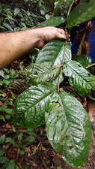  Camellia luongii

Hedychium species nova | Asarum balansae | Camelia luongii
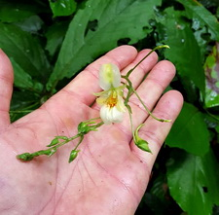  Impatiens parvisepala | 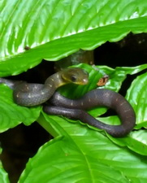  Snake resting on  Amorphophallus tonkinensis | 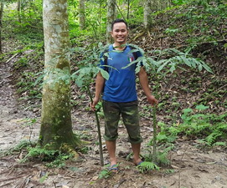  Son Hoang with  Amorphophallus tonkinensis
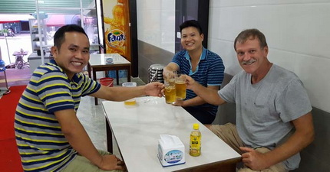
Refueling after a long day

Son Hoang and Alan left Na Hang and met up with an orchid friend of Son Hoang and all 3 of us hiked around Chiem Hoa. We saw another Asarum species growing in tight cracks of rock boulders and several Impatiens species. After lunch Son Hoang and Alan started the drive back south and stayed the night in Tam Dao.
Wednesday, August 22, 2018
Alan’s pics for August 22, 2018:
All photos copyright 2018 to present – Alan Galloway
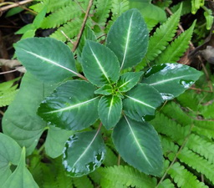 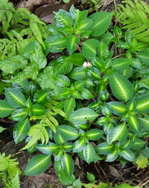 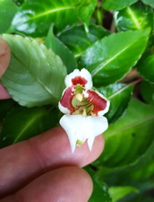
Impatiens morsei

After breakfast and a stop at a coffee shop we hiked around Tam Dao. During the hike we saw several plants of Arisaema petelotii with green seedheads. This is a rhizomatous species with huge trifoliate leaves. One lost count of how many species of Begonias could be seen at this site. It was quite exciting to see Aucuba obcordata, as well as another species growing along the hiking paths. Another unidentied Camellia species was seen as well as another unidentified Magnolia species. After lunch we headed back to Hanoi. Son Hoang and the driver dropped Alan off at the same hotel, but before he left Son Hoang gifted him with a bag of Vietnamese coffee… apparently, he noticed that Alan was addicted to it!
Thursday, August 23, 2018

Alan’s pics for August 23, 2018:
All photos copyright 2018 to present – Alan Galloway
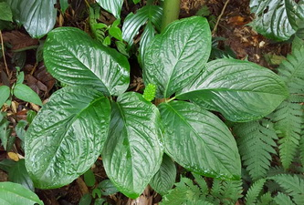  Arisaema petelotii | 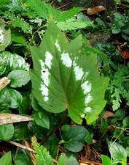  Begonia edulis | 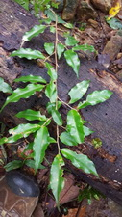  Camelia caudata

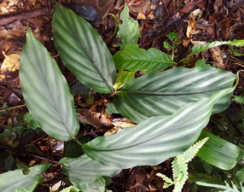  Zingiber collinsii | 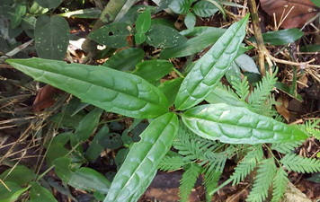  Aucuba species
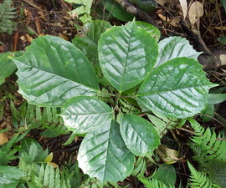  Aucuba cf. obcordata | 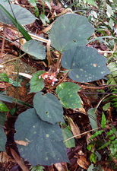  Begonia tamdaoensis | 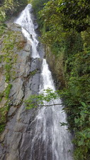  Tam Dao Waterfall
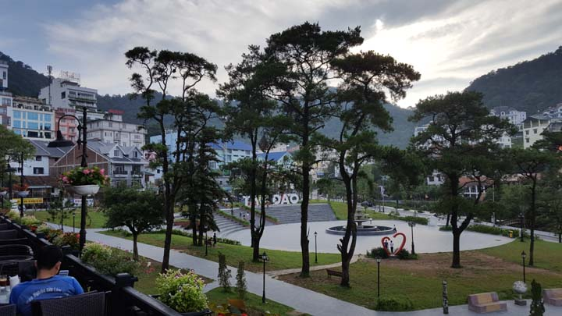
Tam Dao

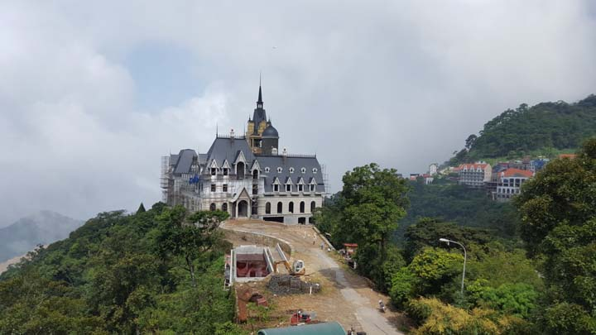
Tam Dao

In the morning Alan flew from Hanoi to Bangkok, Thailand, where he arrived at the older airport. There he exchanged some US dollars into Thai baht and walked across the street to the Amari hotel and met up with Bjørn Malkmus-Hussein and David Prehsler, who arrived in Bangkok the day before. The driver picked us up and we began driving northwest to Sai Yok in Kanchanaburi province. One stop was made before reaching Sai Yok at Krasak Cave. There was found what appeared to be Typhonium trilobatum.
Friday, August 24, 2018

Stop #1 - Sai Yok Noi Waterfall – A few plants of Amorphophallus maxwellii and A. curvistylis could be seen here.
Saturday, August 25, 2018
Stop #2 - Hell Fire Pass (NW of Sai Yok) – Amorphophallus cruddasianus was growing amongst rocks on a sloping hill, along with an unidentified Arisaema species, and several species of Begonia, Globba, Kaempferia, and Zingiber. After hiking around Hell Fire Pass it was almost dark so we headed back to the hotel in Sai Yok.

Alan’s pics for August 25, 2018:
All photos copyright 2018 to present – Alan Galloway
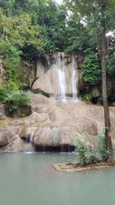  Sai Yok Noi Waterfall | 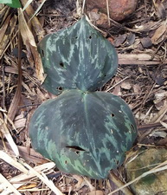 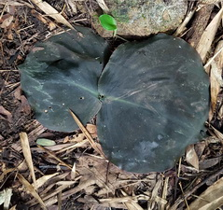  Kaempferia roscoeana
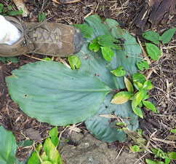  Kaempferia udonensis | 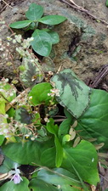  Begonia species | 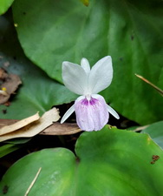  Kaempferia cf. parviflora
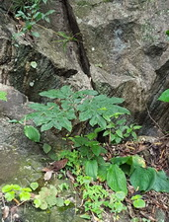  Amorphophallus cruddasianus | 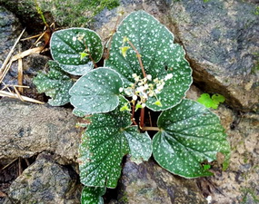  Begonia alicida | 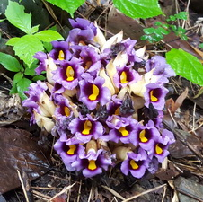  Aeginetia pedunculata

Bjørn’s pics for August 25, 2018:
All photos copyright 2018 to present – Bjørn Malkmus-Hussein
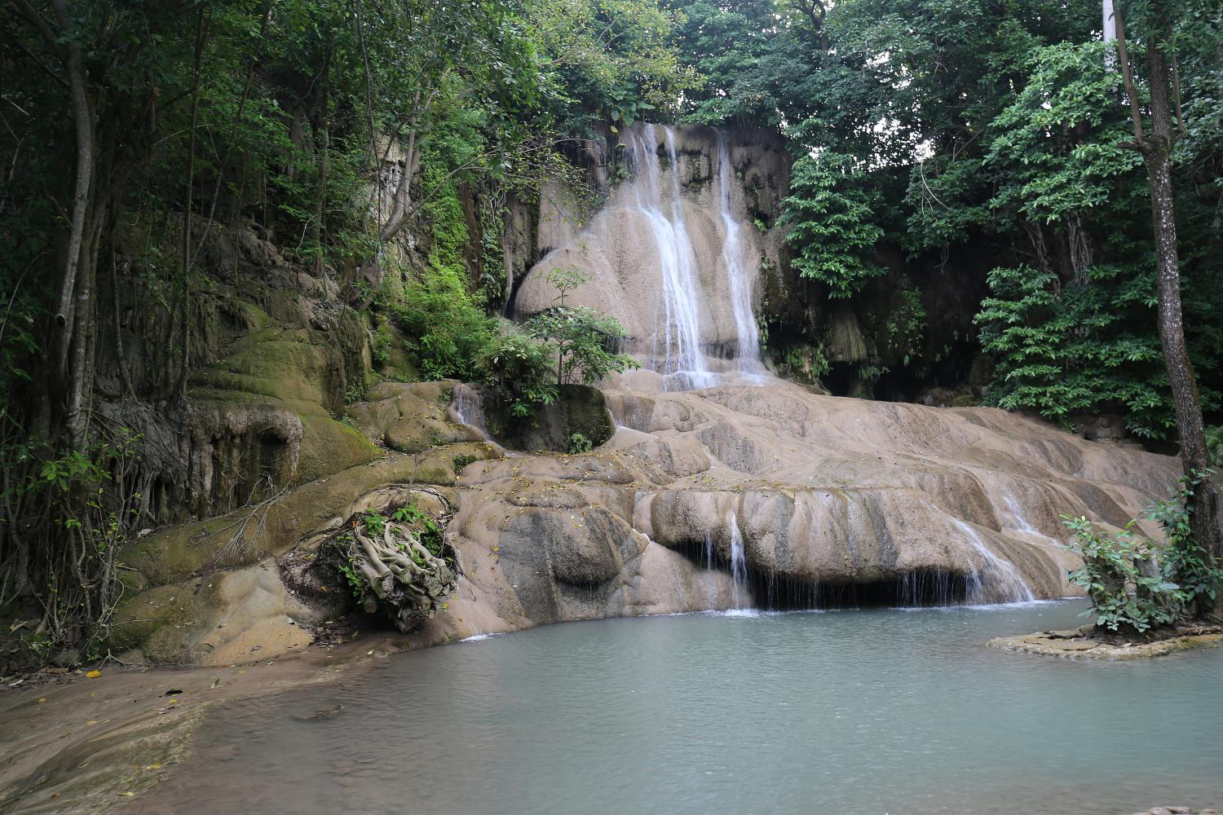
Sai Yok Waterfall

We left Sai Yok and drove northwest toward Thong Pha Phum. Stop #1 - Shortly after leaving Sai Yok, we stopped along the main road just to see what kind of plants we might find. Surprisingly we located Amorphophallus linearis growing on the ditchbanks in rather dry gravel soil. Stop #2 – Just a few feet off the edge of the road we saw a giant form of Amorphophallus paeoniifolius, as well as A. muelleri. Also several species of Alpinia, Boesenbergia, Curcuma and Zingiber were growing here. Stop #3 – Sai Yok Yai Waterfall – The only two interesting plants found at this site were a Globba species and Tacca cf. plantaginea, the latter one growing directly next to and even in the water. Stop #4 – Temple site – We spotted an Amorphophallus species here which belongs to the group formerly classified as a Pseudodracontium. Also seen were colonies of a nicely patterened form of a Hapaline species. Stop #5 - (Northwest of Thong Pha Phum) – Amorphophallus cicatricifer and A. amygdaloides were growing there, along with dense stands of Englerarum hypnosum, all three of them in karst rock cracks. And to everyone’s excitement we also found Sauromatum cf. tentaculatum. Since it was raining, taking photos was nearly impossible, so we all agreed to come back to this site the next morning. We made our way back to Thong Pha Phum and stayed in a hotel along the river.
Sunday, August 26, 2018

Alan’s pics for August 25, 2018:
All photos copyright 2018 to present – Alan Galloway
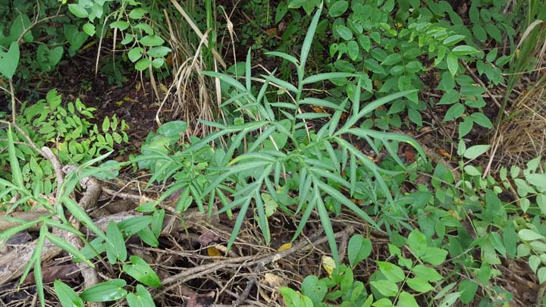
Amorphophallus linearis
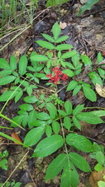  Clerodendrum ??? | 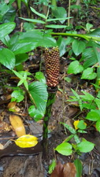  Amorphophallus muelleri seedhead | 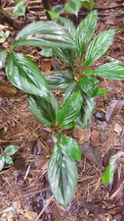  Boesenbergia parvula

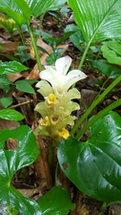  Curcuma aurantiaca | 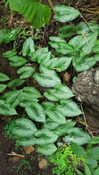  Hapaline species | 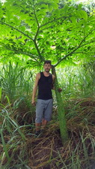  Amorphophallus paeoniifolius
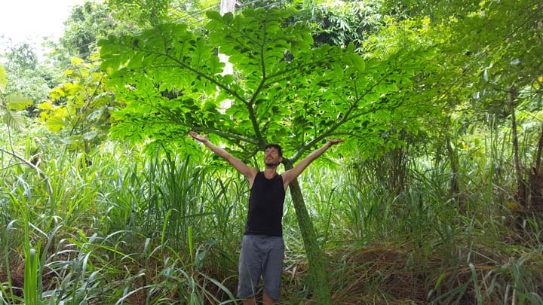
Amorphophallus paeoniifolius

Bjørn’s pics for August 25, 2018:
All photos copyright 2018 to present – Bjørn Malkmus-Hussein
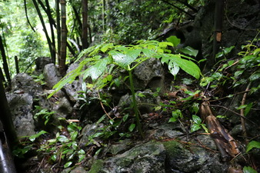  Amorphophallus amygdaloides | 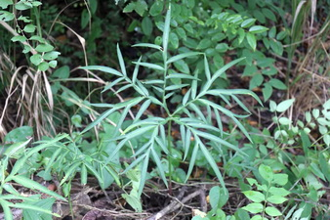  Amorphophallus linearis
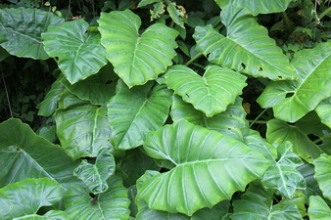  Englerarum hypnosum leaves | `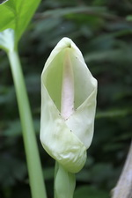  Englerarum hypnosum inflorescence
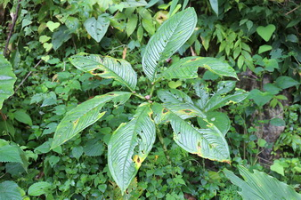  Amorphophallus muelleri | Sauromatum tentaculatum

Stop #1 – We returned to yesterday’s last stop to take some photos. In addition to the species already seen yesterday, we also found an Arisaema species with trifoliate leaves, a near-red flowering Globba species growing in small rock crevices in vertical rock walls, a beautiful silver veined Impatiens species, and several Sauromatum horsfieldii plants and a single specimen of S. hirsutum.
Monday, August 27, 2018
Stop #2 - Between Thong Pha Phum and Khao Laem National Park, we located more Amorphophallus maxwellii and A. amygdaloides, along witha few more plants of Sauromatum cf. tentaculatum. Probably this species is more widespread in Kanchanburi province if habitat is suitable: shaded spots in almost vertical rock walls which seem to retain more moisture during the dry season. It was early afternoon and we were approaching Sangkhla Buri, much too early to start the daily hotel search, so we opted to drive north about 45 minutes to Three Pagodas Pass at the Thai/Myanmar border. There is a small market and sometimes some nice plants are being sold by the Myanmar locals. Bjørn found some Curcuma cultivars that he couldn’t live without. We ended the day at a hotel back in Sangkhla Buri.
Alan’s pics for August 27, 2018:
All photos copyright 2018 to present – Alan Galloway
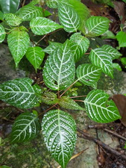  Impatiens species | 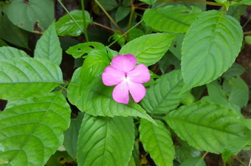  Impatiens species | 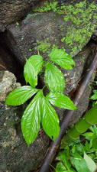  Sauromatum tentaculatum

As we now had reached our most distant point from Bangkok, we started our trip back.
Tuesday, August 28, 2018
Stop #1 - Between Sangkhla Buri and Khao Laem National Park – Even though this area was quite hilly and covered with forest, it was extremely wet. We really didn’t expect to find any Amorphophallus species in this kind of habitat, but much to our surprise we located 2 species that were not identifiable neither from their leaves nor the location, so perhaps they are new species. One of the species found by Bjørn had nearly black petioles and also formed intercalary bulbils. In the other species the fruits were maturing to near-white in color. On a very steep and open clay wall we encountered a nice colony of Monolophus, a tiny ginger with relatively large flowers – the only record of that genus for the whole trip.
Stop #2 – At this site we found an Amorphophallus species from the formerly recognised genus Pseudodracontium that was nearly a meter tall with lanceolate leaflets.
Stop #3 – Kroeng Krawia Waterfall – Southeast of Khao Laem National Park – Again we found more Amorphophallus maxwellii and A. amygdaloides at this site. Given that we had now seen hundreds of plants of these 2 species, we began to take note of the variation in the petiole pattern and coloration. We noticed that the petioles of A. maxwellii could be nearly solid black, green, or even white… the color variation was just amazing! Rocks around the waterfall were overgrown with a lovely display of Begonia prolifera and Argostemma lobbii, both growing in a very thin layer of moss.
Stop #4 – Between stop #3 and Thong Pha Phum - David found the Amorphophallus species that was on Alan’s ‘target’ list – one he had found already some 15 years earlier that most likely is an undescribed species. This Thai species seems to have a disjunct look-alike in northern Vietnam. Bjørn also saw Curcuma rubrobracteata here with showy bright red bracts. We stayed at the same hotel at the river from 2 days earlier in Thong Pha Phum.
Alan’s pics for August 28, 2018:
All photos copyright 2018 to present – Alan Galloway
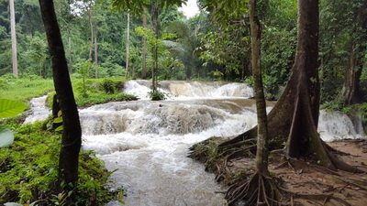 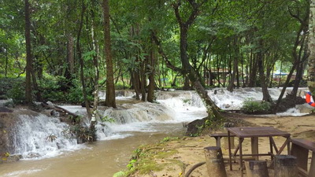
Kroeng Kra Wia Waterfall
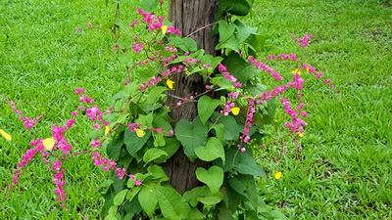  Antigonen leptopus | 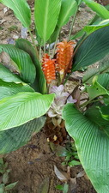  Curcuma aurantiaca (front)  Curcuma roscoeana (rear) | 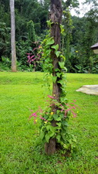  Antigonen leptopus
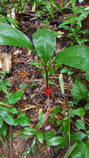 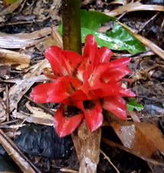  Curcuma rubrobracteata | 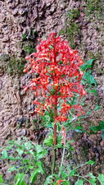  Clerodendrum  paniculatum | 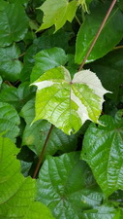  Variegated vine

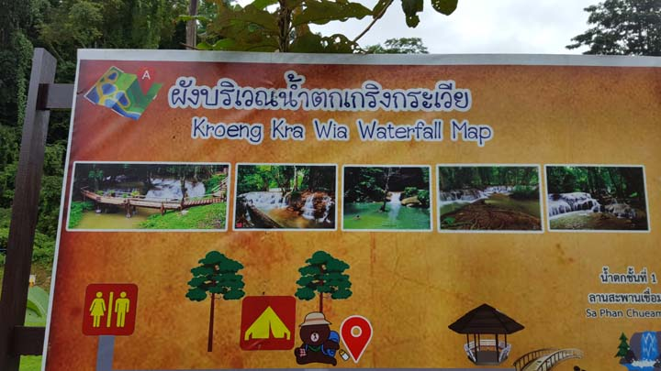
Kroeng Kra Wia Waterfall

Bjørn’s pics for August 28, 2018:
All photos copyright 2018 to present – Bjørn Malkmus-Hussein
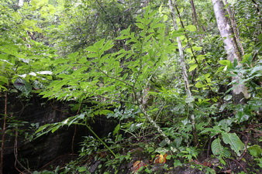  Amorphophallus maxwellii | 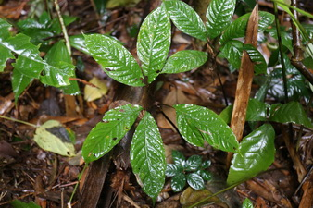  Amorphophallus spc. nov. intercalary bulbils

Stop #1 – Since it was approaching sunset yesterday when we were at this site, we returned back to the last stop from yesterday to take some photos.
Wednesday, August 29, 2018
Stop #2 – between Thong Pha Phum and Sai Yok – We had almost given up on finding some of the other ‘target’ plants to take some photos, but at least this stop provided us the opportunity to capture photos of Amorphophallus cirrifer and A. longituberosus, both growing in rather dry gravel soil.
Stop #3 (after lunch) – David located a Typhonium species wedged in the crack of a vertical rock wall about 3 meters above the ground. Since he wanted to get a photograph of it, he had to climb on Alan’s shoulders to get it to eye level. We ended the day staying in the same hotel in Sai Yok as we stayed in a few days earlier.
Alan’s pics for August 29, 2018:
All photos copyright 2018 to present – Alan Galloway
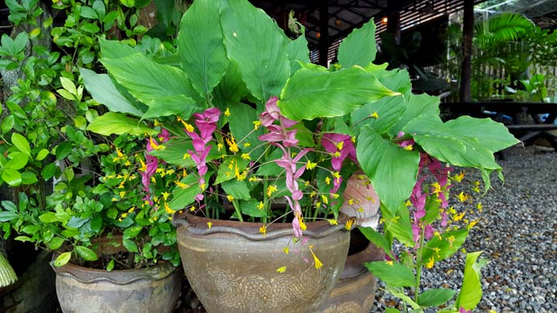
Globba species

We left Sai Yok and returned to August 26 Amorphophallus linearis stop
Stop #1 – We were so excited to find Amorphophallus linearis a few days earlier, we all forgot to take any photos, so we made a quick return to that site.
Stop #2 – From Sai Yok, we drove southeast to the 1st temple stop on a side road to Erawan Waterfall – We did not find any exciting plants at this stop, but we all got a good leg workout from climbing the Temple&rsquo;s steps!
Stop #3 – On the main road to Erawan Waterfall – Here were growing a beautiful form of Typhonium laoticum with silver leaves, and a stunning lavender flowered Impatiens species. We were all blown away by the variation of leaf patterns of Kaempferia roscoeana that were wedged into the karst rocks. We also found what we think was a very fine-leafed form of Amorphophallus longituberosus.
Thursday, August 30, 2018
Stop #4 – Erawan Waterfall – This is one of Thailand&rsquo;s National Parks with stunning waterfalls. We were not quite sure what to make of the diamond shaped sign with a cobra painted on it along the walking path! We would have loved to see one king cobra (from a distance), but they seem to be extremely shy.
Stop #5 – On the same side road as stop #2 – 2nd temple stop – As we climbed up the steep hill behind the temple, we saw a beautiful form of Amorphophallus cf. macrophyllus, and what we think may be a new species of Amorphophallus with deep green leaflets and margined in magenta; this species has started showing up in collections in recent years. Tubers were growing deeply buried in very narrow rock cracks. After this stop we continued on to Kanchanaburi City to find a hotel for the night.

Alan’s pics for August 30, 2018:
All photos copyright 2018 to present – Alan Galloway
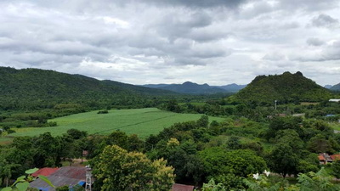 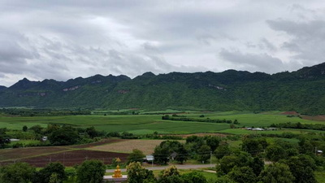
Kanchanaburi Province
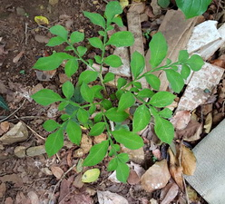Amorphophallus cirrifer | 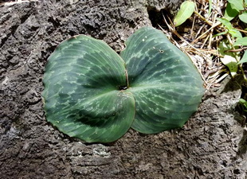 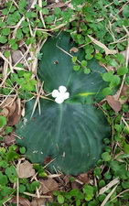Kaempferia roscoeana

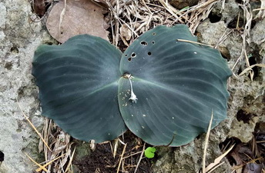 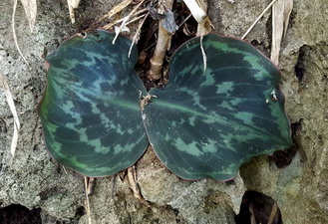 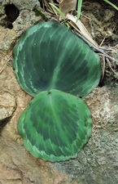
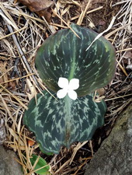 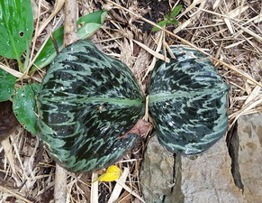 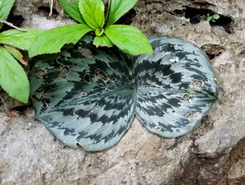
Kaempferia roscoeana
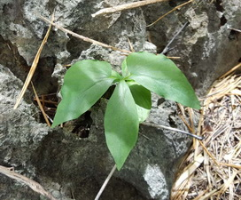  Typhonium cf. laoticum | 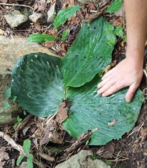  Kaempferia udonensis | 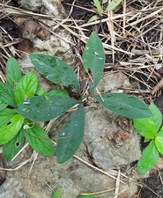  Amorphophallus species

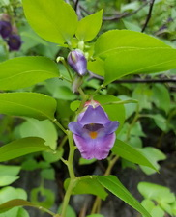 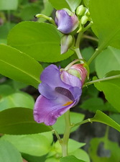 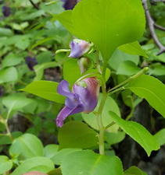  Impatiens cf. namchabarwensis | 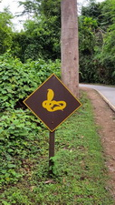  Cobra crossing road sign

Bjørn’s pics for August 30, 2018:
All photos copyright 2018 to present – Bjørn Malkmus-Hussein
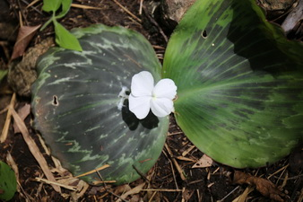  Kaempferia roscoeana | 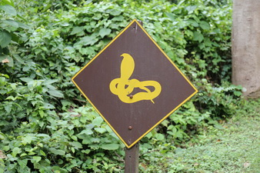  King Cobra sign at Erawan Waterfall

After breakfast we departed Kanchanburi City for the long drive back to Bangkok. Derek had already made hotel reservations for all of us very near the new airport, so check-in was quite fast. After dinner David went to the airport to pick up Derek.
Friday, August 31, 2018

We arrived at the Bangkok airport with enough time to have breakfast together and to map out where we would be traveling in Laos. Once we arrived in Vientiane, we got our visas on arrival, exchanged some US dollars into Lao kip and met the driver in front of the terminal. Since it was approaching lunch time, we asked the driver to find us a place to eat, so he carried us to one of his favorite places to eat. We made a quick stop to pick up some bottled water and snacks and spent the rest of the day driving south on highway 13, the main north/south road in Laos. Once we reached the town of Paksan, we took the road north to Borikhan and found a hotel for the evening.
Saturday, September 1, 2018

We left Borikhan and headed north, then east, and then south towards highway 8.
Sunday, September 2, 2018
Stop #1 – Since we had been driving for a few hours, this was more of a ‘stretch your legs’ stop than a stop to look for plants.
Stop #2 – After seeing miles and miles of flat rice fields, we spotted a single karst mountain rising from the rice paddies and found it to be quite abundant with interesting plants. Here we located Amorphophallus bolikhamxayensis (several specimens were fruiting), a fairly large leafed and probably new Typhonium species, a pale pink flowering Impatiens species, a nice yellow flowering Globba species and large stands of Calanthe orchids, probably C. vestita, which must make quite an impressive aspect when in flower.
Stop #3 – A fairly steep hill with a water stream. Probably all of us ended up slipping down multiple times from all the wet dirt. Some very tall forms of Disporopsis longifolia were in full fruit. We also found 2 potentially new Amorphophallus species at this site.
Stop #4 – After lunch, a second water stream – Bjørn found an Aglaonema species with huge ripe fruits.
Stop #5 – Karst mountain – We spotted more Amorphophallus bolihamxayensis, a nicely spotted leaf Aspidistra species and a trifoliate-leafed Arisaema species from section Anomala. Since it was beginning to get dark, we decided to make our way southward to highway 8 and then westward to Lak Xao to find a hotel.
Alan’s pics for September 2, 2018:
All photos copyright 2018 to present –
Alan Galloway
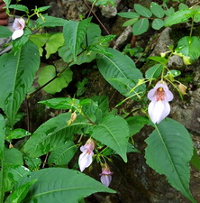
Impatiens species

Bjørn’s pics for September 2, 2018:
All photos copyright 2018 to present – Bjørn Malkmus-Hussein
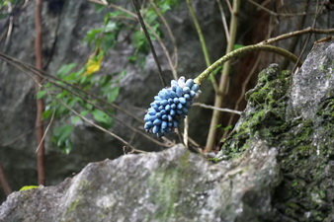  Amorphophallus bolikhamxayensis  infrutescence | 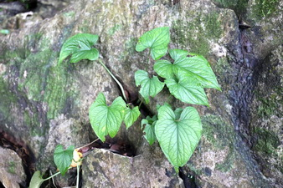  Typhonium spec. nov.
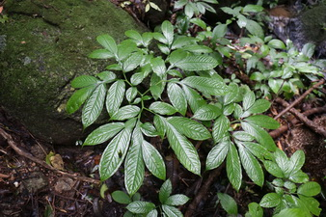  Amorphophallus spec. nov. 1 | 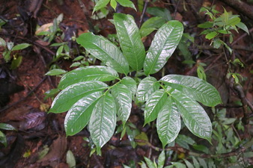  Amorphophallus spec. nov 2

From Lak Xao, we drove east toward the Vietnamese border.
Monday, September 3, 2018
Stop # 1 – very close to the border – Since it had rained a few hours before sunrise, everything was soaking wet, but after a couple of minutes trekking from the roadside, this area proved quite rich in Amorphophallus. We saw what we think may be 4 new species, as well as finding a very large species that might have been Amorphophallus kachinensis. Bjørn, David and Derek were waiting by the van till Alan came down the hill. Alan was curious as to why everyone was pointing at him. Once Alan looked down at his legs he realized the reason. He had about 30 leeches on each leg and quite a bit of blood! Leeches are covered with some kind of slime, once you touch them, the slime prevents you from grasping anything with your fingers, so he had to carve them off his legs with a pocketknife. Since he was the elder member of the team, David began the chant, ‘Papa don’t leech’.
We returned to Lax Xao and then went south.
Stop #2 – The trees had been logged from most of this area for timber and the remaining areas were converted into rice paddies, so there were not many areas to find interesting plants.
We returned back to Lak Xao for lunch. While sitting in the restaurant waiting for our food, a larger leech had filled itself on Alan’s blood, fallen off and started crawling across the restaurant floor just as the waitress was bringing out our food. The poor woman went screaming back to the kitchen area.
Stop #3 – After lunch we went west to the site where Petra Schmidt, Annop Ongsakul and Alan discovered Amorphophallus arcuspadix back in 2003. At that time there were thousands of plants growing in the area, but since the trees had grown so much in the past 15 years, they had shaded out the area and we only saw a few remaining plants growing in rock crevices.
We returned to Lak Xao and went north. As we did not find any good places to search for plants, we decided to head back to the hotel in Lak Xao.
Alan’s pics for September 3, 2018:
All photos copyright 2018 to present – Alan Galloway
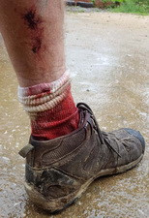  Attacked by leeches | 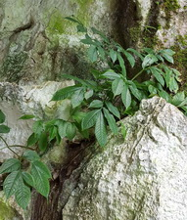  Amorphophallus arcuspadix
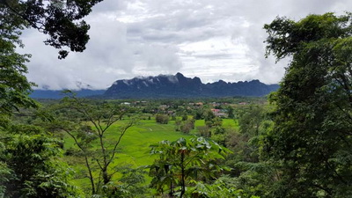  Overlooking Lak Xao | 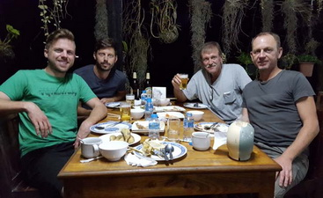  The gang at dinner
Tuesday, September 4, 2018
We left Lak Xao and drove westward to Ban Phônkho.
Stop #1 – just west of Lak Xao – Growing in heavy shade, we found a beautiful silver centered form of a Peliosanthes species - and more leeches.
Stop #2 – Dragon Cave – Central Laos features numerous caves in karst mountains and when these are found along the roadside, they make for great tourist stops. Here we found a beautiful pale pink Impatiens species, a bright red-bracted Zingiber species and 2 species of Habenaria orchids.
Stop #3 – Our next stop was at the site where Amorphophallus pulchellus was originally discovered. Sadly this site has practically been destroyed due to development. We were only able to find a single, rather young plant to photograph – probably the last of its species. Fortunately, this species is quite prolific in cultivation and thus in the long term it may survive at least ex situ.
Stop #4 - Here we found Amorphophallus bolikhamxayensis, which seems quite wide-spread in this area, almost always confined to karst formations.
Stop #5 (after lunch) – Water stream near Ban Phônkho – growing in wet areas we found a single patch of an Amorphophallus species with glossy leaflets and which may turn out to be a new species.
Stop #5 – Our last stop of the day was the original site where Amorphophallus barbatus was discovered. It was nice to find a handful of additional plants scattered in a larger area than originally seen, although they were extremely sparse and it took a lot of rock climbing to explore this area. At the same site we were also looking to rediscover an undescribed Amorphophallus species which we had seen there on an earlier excursion back in 2015. It belongs to a group of tiny species which have all been described in recent years and are known from central Laos only: A. claudelii, A. myosuroides, A. ongsakulii and A. pulchellus.
We made our way back to Ban Phônkho, finding a hotel right at sunset. We drove to a restaurant that was popular among truckers. By the time our food arrived and we had eaten, our van had gotten boxed in by several big trucks. It took quite some time for the restaurant owner to get the truck owners to move their trucks so we could leave.

Alan’s pics for September 3, 2018:
All photos copyright 2018 to present – Alan Galloway
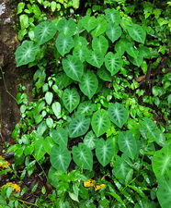  Colocasia heterochroma | 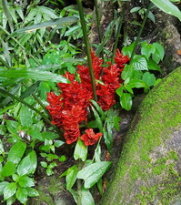  Zingiber species | 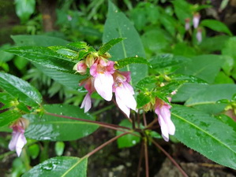  Impatiens morsei
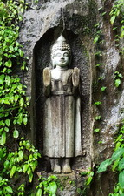  Statue | 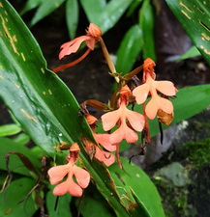  Habenaria rhodocheila | 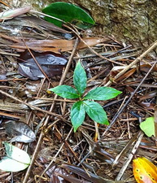  Amorphophallus pulchellus

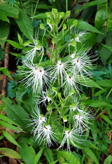 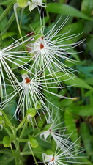  Habenaria medusa |  | 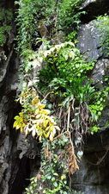  Amorphophallus bolikhamxayensis
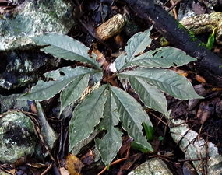  Amorphophallus barbatus | 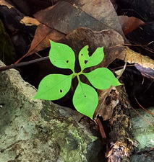  Amorphophallus malkmus-husseinii | 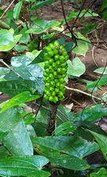  Amorphophallus laoticus  seedhead

Derek’s pics for September 3, 2018:
All photos copyright 2018 to present – Alan Galloway
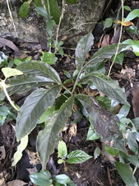
Amorphophallus barbatus

Bjørn’s pics for September 4, 2018:
All photos copyright 2018 to present – Bjørn Malkmus-Hussein
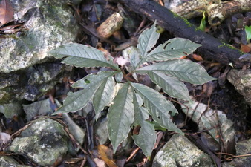  Amorphophallus barbatus | 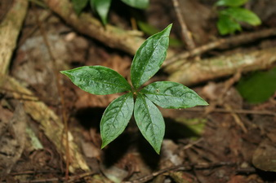  Amorphophallus pulchellus
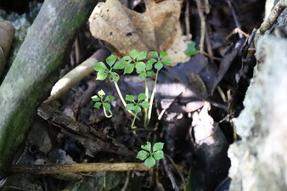  Amorphophallus malkmus-husseinii at  Amorphophallus barbatus site | 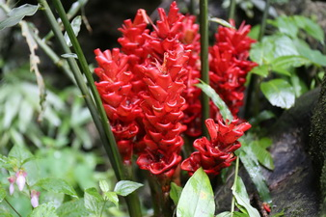  Zingiber spec. at Dragon Cave

We left Ban Phonkho and drove west to Ban Lao and then south on highway 13.
Wednesday, September 5, 2018
Stop #1 – South of Ban Lao we found Amorphophallus croatii and A. crispifolius, as well as a solid green-leafed Peliosanthes species.
Stop #2 – Just north of Thakhek we took a side road to search for the original location of Amorphophallus claudelii. We were not able to find the original site, but at a stop in the general vicinity we were able to locate a few specimens. Also here we found A. laoticus growing.
We continued onto Thakhek and found a hotel right on the Mekong River. Our timing was perfect to get some great shots of the sun setting over the Mekong.

Alan’s pics for September 5, 2018
Copyright 2018 to present – Alan Galloway
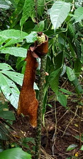  Amorphophallus croatii seedhead | 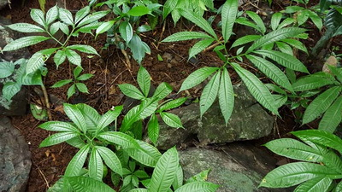 Amorphophallus crispifolius
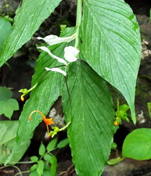  Globba species | 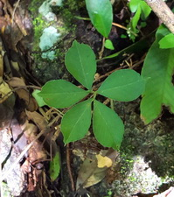  Amorphophallus claudelii
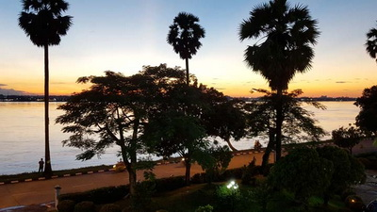  Sunset over the Mekong River | 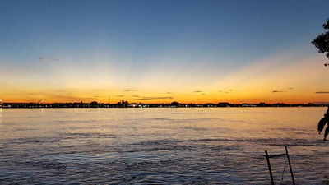  Sunset over the Mekong River

  Naga at the edge of the Mekong River | 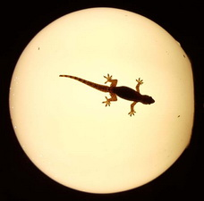  Gecko on the moon?

Bjørn’s pics for September 5, 2018
Copyright 2018 to present – Bjørn Malkmus-Hussein
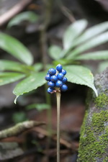  Amorphophallus crispifolius infrutescence | 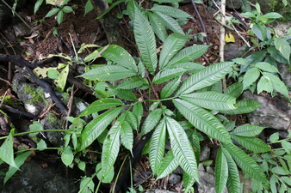  Amorphophallus crispifolius 1
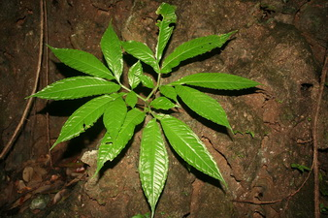  Amorphophallus crispifolius 2 | 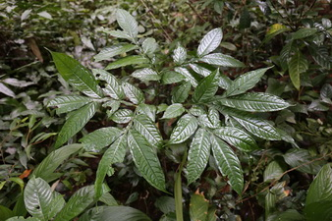  Amorphophallus croatii

  Naga Dragon at Mekong in Thakhek |   View Over Mekong River at Sunset from Thakhek
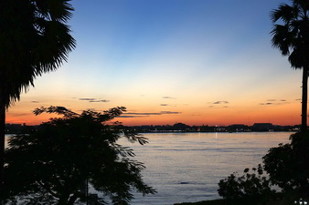
View Over Mekong River at Sunset from Thakhek

Thursday, September 6, 2018
After breakfast we left Thakhek and headed east on highway 12 toward Gnommalat. We made several stops today finding Amorphophallus coudercii, A. gallowayi, A. laoticus, A. myosuroides and just a handful of A. ongsakulii at the original site of this species, several Begonia species, the stunning silver centered Impatiens morsei and once again - more leeches.
We stayed in Fang Deng (very near Gnommalat).

Alan’s pics for September 6, 2018
Copyright 2018 to present – Alan Galloway
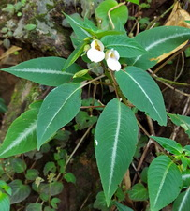 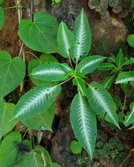  Impatiens morsei |  | 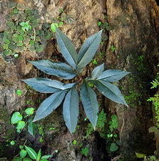  Amorphophallus galowayi
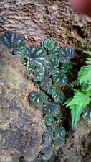  Begonia hinnamnoensis | 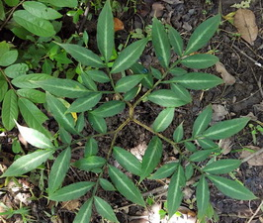  Amophophallus laoticus | 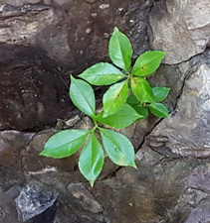  Amorphophallus myosuroides

Derek’s pics for September 6, 2018
Copyright 2018 to present – Derek Carwood
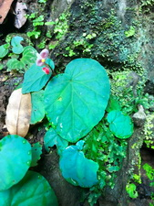 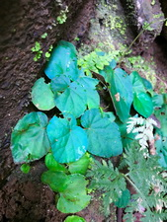
Blue-leafed Begonia sp. with flower

Bjørn’s pics for September 6, 2018
Copyright 2018 to present – Bjørn Malkmus-Hussein
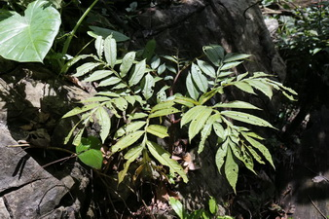  Amorphophallus ferruginosus | 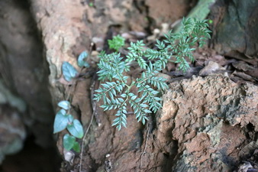  Amorphophallus ongsakulii
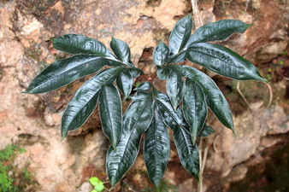  Amorphophallus gallowayi 1 | Amorphophallus gallowayi 2

We left Fang Deng and drove east toward the Vietnamese border. We made several stops during the day finding Amorphophallus kachinensis and A. khammouanensis. Along a stream with large boulders we found the stunning miniature Begonia hymenophylla with relatively large pink flowers growing in the moss on the boulders. At one of the stops we spotted lots of A. ferruginosus plants growing, with some of them having ripe seed heads. Also, the very large leafed Colocasia gigantea is fairly common in this area.
Friday, September 7, 2018
We returned back to Fang Deng and stayed at the same hotel as last night. Since there was only one restaurant in Fang Deng we had several meals there and the restaurant owners had learned we were serious coffee drinkers (or rather coffee addicts) so by the second day they were bringing us coffee even before we were out of the van.

Alan’s ppicss for September 7, 2018
Copyright 2018 to present – Alan Galloway
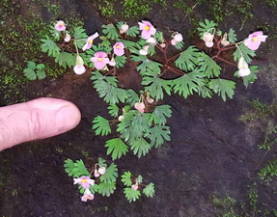 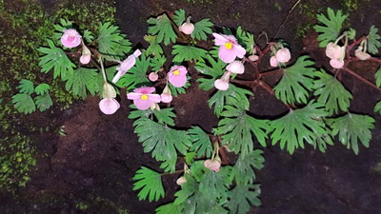 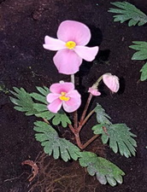
Begonia hymenophylla

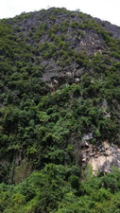  Karst Mountain – central Laos | 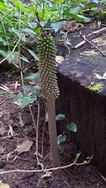  Amorphophallus paeoniifolius seedhead
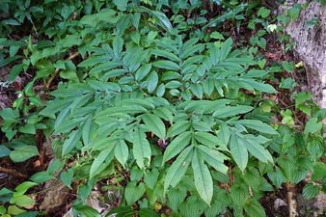  Amorphophallus ferruginosus | 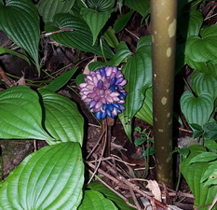  Amorphophallus ferruginosus seedhead

Bjørn’s pics for September 7, 2018
Copyright 2018 to present – Bjørn Malkmus-Hussein
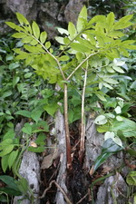  Amorphophallus ferruginosus | 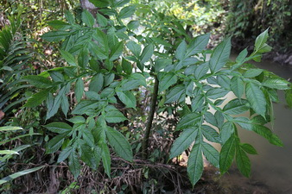  Amorphophallus kachinensis
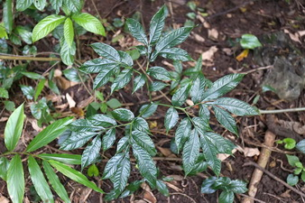  Amorphophallus khammouanensis | 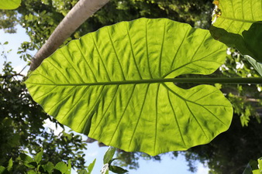  Colocasia gigantea

We left Fang Deng and drove west toward Thakhek, making several stops along the way. We found a couple of Zingiber species, several Begonia species and at least 2 Crinum species. Also seen were Amorphophallus ferruginosus, A. gallowayi, A. laoticus, A. crispifolius, A. myosuroides, A. longituberosus, A. coudercii and Typhonium laoticum. At the second to last stop we found a large hawkmoth caterpillar feeding on the leaflets of A. laoticus. Our very last stop of the day before returning to our hotel in Thakhek was a cave site. Surprisingly we found a second population of A. ongsakulii. The original population has been overgrown by more competitive plants and only a handful of younger specimens are left at that site. Thus the location of a second and apparently more stable population was quite interesting.
Saturday, September 8, 2018
Alan’s pics for September 8, 2018
Copyright 2018 to present – Alan Galloway
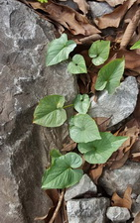  Typhonium cf. laoticum | 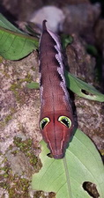  Caterpillar eating  Amorphophallus leaves | 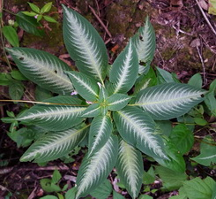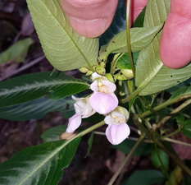  Impatiens species

Derek’s pics for September 8, 2018
Copyright 2018 to present - Derek Carwood
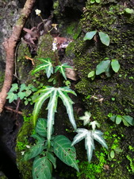
Begonia sp. “fox begonia”

Bjørn’s pics for September 8, 2018
Copyright 2018 to present – Bjørn Malkmus-Hussein
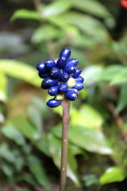  Amorphophallus crispifolius  infrutescence | 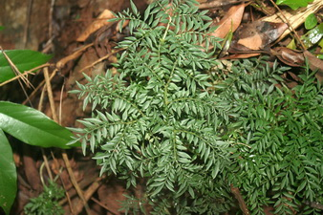  Amorphophallus ongsakulii
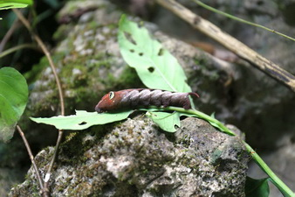
Hawkmoth Caterpillar on Amorphophallus laoticus

After a hearty breakfast we departed Thakhek and drove north toward Ban Lao on highway 13. We decided to make a return to the stop we made on our way down on the same highway, where we found Amorphophallus croatii to get a few more photos. We decided to climb higher up the mountain than we had earlier and found a Globba species in bloom with white bracts and nicely constrasting orange flowers, as well as a new Amorphophallus species which seems to be related to A. schmidtiae.
Sunday, September 9, 2018
Since we reached Ban Lao by lunch, we opted to drive back east on highway 8. We made a few stops along this road finding Amorphophallus brevipetiolatus, A. schmidtiae, as well as an undescribed species that Petra, Annop and Alan had previously found back in 2003.
We returned back to Ban Lao just before dark and located a hotel for the night.
Alan’s pics for September 9, 2018
Copyright 2018 to present – Alan Galloway
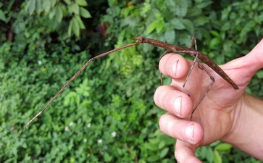  Stick insect | 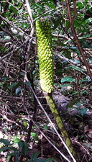  Amorphophallus laoticus seedhead
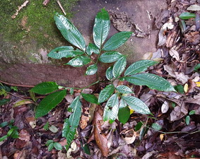  Amorphophallus brevipetiolatus | 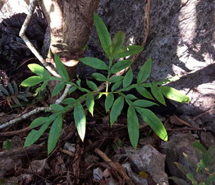  Amorphophallus schmidtiae

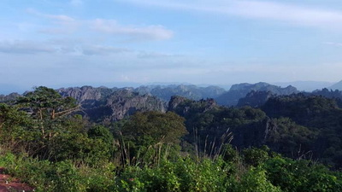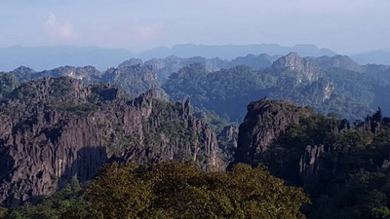

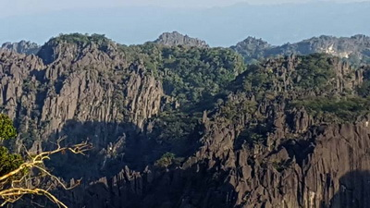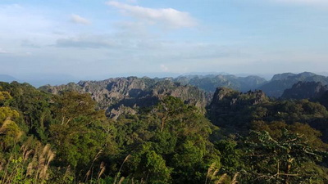
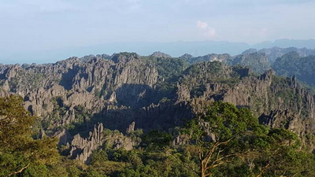 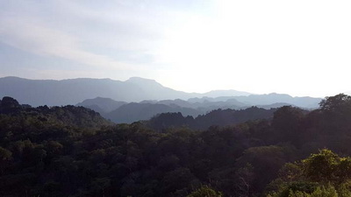
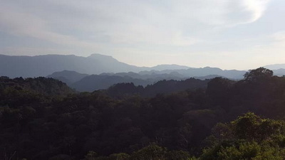
Karst Mountains – central Laos

Bjørn’s pics for September 9, 2018
Copyright 2018 to present – Bjørn’ Malkmus-Hussein
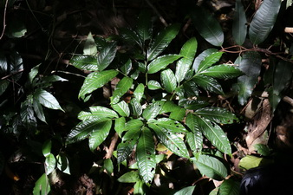  Amorphophallus brevipetiolatus 1 | 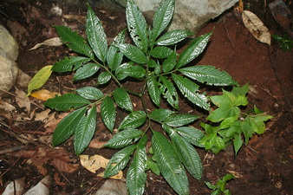  Amorphophallus brevipetiolatus 2
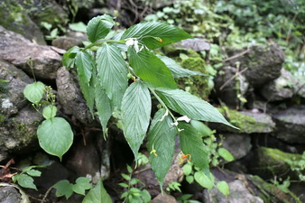  Globba spec. white bracts  orange flowers | 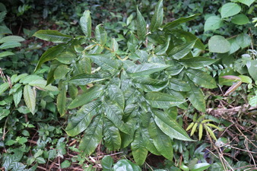  Amorphophallus schmidtiae  (pale brown form)
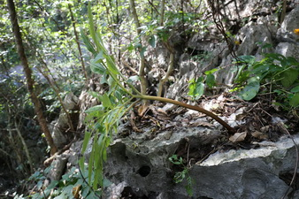
Amorpophallus schmidtiae

As Alan was sitting on the steps of the hotel waiting for the other guys to bring out there luggage, a tiny bird flew into a hotel window and fell to the ground unconscious. Alan picked it up before the local cat could get to it and noticed it was still alive. After about 15 minutes it came back to life and flew off. The little bird; was a Little Spiderhunter (Arachnothera longirostra). We left Ban Lao and drove back to Vientiane, a rather long drive on a road in much need of pothole repairs. Once we arrived in Vientiane, we stayed in a hotel right on the Mekong River. Our driver carried us to a fantastic restaurant for dinner, as it was our last meal together with him.
Monday, September 10, 2018

Alan’s pics for September 10, 2018
Copyright 2018 to present – Alan Galloway
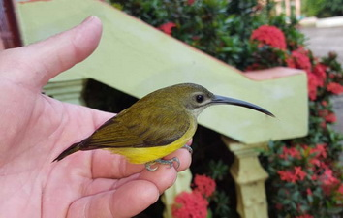
Little Spiderhunter
(Arachnothera longirostra)

Bhørn’s pics for September 10, 2018
Copyright 2018 to present – Bjørn Malkmus-Hussein
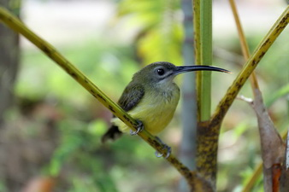
Arachnothera longirostra

We flew from Vientiane back to Bangkok. Once we arrived in Bangkok, we made our way to the hotel. After lunch David, Derek and Alan visited Barry Yinger’s nursery (https://www.newlifetropicals.com/) where Barry spent the afternoon touring us around his plant collection. As expected he still has a huge interest in variegated plants and probably has one of the largest collections of Sansevieria.
Tuesday, September 11, 2018

Derek’s pics for September 11, 2018
Copyright 2018 to present – Derek Carwood
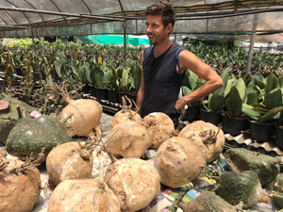  David at Barry Yinger's Nursery | 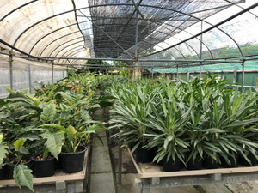  Barry Yinger's Nursery

After eating breakfast in the hotel lobby we went to Chatuchak market where we spent several hours walking around looking at plants. This market probably has the greatest variety of plants for sale anywhere in the world. The afternoon was spent inventorying and cleaning plant material that was purchased at nurseries along the way in preparations for phytosanitary inspection the next day.
Wednesday, September 12, 2018

Alan’s pics for September 12, 2018
Copyright 2018 to present – Alan Galloway
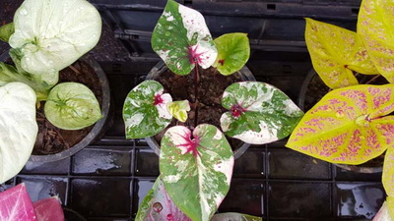  Caladium hybrids at Chatuchak Market | 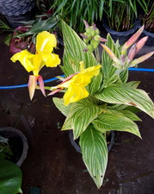  Canna at Chatuchak Market | 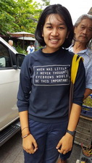  Winner of ‘Best T-shirt  at Chatuchak

Since we were some of the first people to arrive at the plant inspection station, we were ‘used’ as the training subjects for some of the new inspector trainees, which caused us to stick around until almost noon. Luckily, there was a coffee shop right down the street! We made our way back to the hotel for a few hours of rest before having our last dinner together with delicious, freshly made Thai food in a nearby restaurant.
Bjørn and Alan left the hotel at 7pm for the airport. Alan’s plane departed at 10:40pm, with Bjørn’s departing about 45 minutes later. David and Derek were able to get a few more hours of rest as their flights did not leave until Friday morning.
Thursday, September 13, 2018
Bjørn’s pics for September 13, 2018
Copyright 2018 to present – Bjørn Malkmus-Hussein
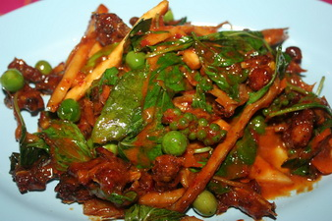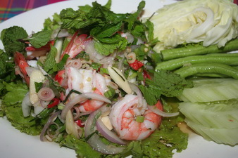
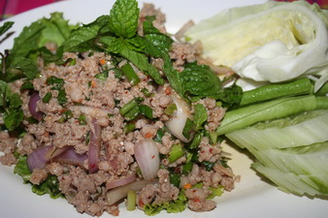
Food Thailand

After leaving Bangkok, Alan had a stopover in Seoul, South Korea and then Atlanta. Since he had several hours in the Atlanta airport he was watching the news of Hurricane Florence that was scheduled to come over Raleigh the same time he was due to land in Raleigh. He was expecting his flight into Raleigh to be canceled, but it took off on time. His landing in Raleigh was one of the roughest airplane landings he ever experienced due to the hurricane winds.
Friday, September 14, 2018
Bjørn arrived at Frankfurt airport, Germany in the early morning. He stayed over a couple of days at his parents’ house in his original hometown of Wiesbaden before heading on to Tenerife, Canary Islands, Spain. As he had developed some serious illness with persistent headaches, high fever and imbalance during his stay in Wiesbaden, he went from Tenerife airport straight to the emergency at the local university hospital. Despite having done all available tests on tropical diseases in the forthcoming days, it could not be figured out what it was. Fortunately dengue, malaria, Japanese encephalitis, and all forms of typhoid fever could be discarded though. Symptoms lasted almost three weeks and then they gradually disappeared.
David and Derek had very comfortable flights home, fortunately without any troubles.

